funded by the
Stewarding Cultural Heritage: Latino Art, Museums, and Preservation Fellowship (LAMP Fellowship)
Institute of Museum and Library Services

APPLICATION MATERIALS
The University of North Texas College of Information, College of Visual Arts and Design instituted this fellowship program to provide financial support to students seeking a Graduate Academic Certificate (GAC) in Art Museum Education or Cultural Heritage Stewardship. The Institute of Museum and Library Services (IMLS) wishes to provide support to recruit, train, and develop the workforce related to Latino Museums. IMLS monies fund the scholarship.

APPLICATION AND SCHOLARSHIP CONDITIONS
The LAMP Fellowship will pay tuition and fees, stipends, and internship travel costs up to $14,000. Applicants must complete and submit an original of the application form (page 3 below) and all required materials (detailed on pages 3-5 below).
DEADLINE: Applications will be reviewed on a rolling basis. Applications will be accepted on a rolling basis until admissions all 6 cohort positions have been filled each year. Currently, both the first-year and second-year applications are open.

In order to be eligible for the LAMP Fellowship, the applicant must:
- Meet the UNT Toulouse Graduate School and departmental admission criteria for the Graduate Academic Certificate (GAC) in Art Museum Education, or MS LS/IS in archival studies concentration.
- Apply to the UNT graduate school for GAC in Art Museum Education, or MS LS program in archival studies concentration, and be eligible to take graduate coursework for the LAMP Fellowship.

All LAMP Fellowship recipients are expected to:
  - Begin the UNT GAC program in the spring of 2024, or fall of 2024, or fall 2025 and complete the coursework for the program within one calendar year
  - Take two courses per semester and a total of 15 UNT credits in the LAMP Fellowship cohort
  - Remain academically eligible as a UNT graduate student
  - Agree to participate in the internship at the grant’s partner institution - Mexican American Civil Rights Institute (MACRI) in San Antonio, TX - for at least 120 hours.

All applications will be kept on file at the University of North Texas College of Information, acting as LAMP Fellowship coordinator and fiscal agent.

All applications must be typed. E-mailed applications will be acceptable with all materials digitized into electronic files in pdf format. No faxed applications will be accepted.

To help ensure that the applicant's file is complete by the deadline, all documents must be submitted in one package. Email the documents to yunfei.du@unt.edu, and submit your complete application package to:

Shipping Address (FedEx, UPS, USPS etc.):
Yunfei Du, Professor and Associate Dean of Academics
Project Manager of the UNT/LAMP Fellowship Program
University of North Texas
College of Information
3940 N. Elm, E290H
Denton, TX 76207

LAMP Fellowship Application
Please follow the directions and complete your application as soon as possible. Applications will be reviewed on a rolling basis. Applications will be accepted through January 12, 2023, with priority given to applications received by November 15, 2023. Admissions for the first year will be closed after all of the 6 cohort positions have been filled.
Name:
Present Mailing Address:
Phone: Home Phone: Work Phone: Cell
Email address:
How did you learn about the LAMP Fellowship?

Are you currently enrolled in a UNT graduate program?
Yes No
If you are not enrolled at UNT, have you submitted your application to GAC Art Museum Education or MS LS/IS in Archival Studies to UNT through AppTexas.org?
Yes No
Do you currently work or volunteer in a museum? Yes No

Do you work? • Full-time • Part-time • Volunteer

If yes, what is your job title:

Please describe your current job duties and responsibilities:
Ethnic background: For reporting purposes only, we would appreciate an indication of which of the following groups best describes your ethnic background.
  - African American
  - American Indian/Alaska Native
  - Asian
  - Hispanic/Latino
  - Native Hawaiian/Pacific Islander
  - White/Caucasian
  - Other:
In addition to the application form, applicants are required to include the following materials
Part 1. EDUCATION AND WORK HISTORY
Submit your resume including academic and work history and contact information for places of employment.

Part 2. COMMUNITY INVOLVEMENT STATEMENT
Summarize your participation in community and/or campus activities and/or community service organizations in the past three years.

Part 3. ESSAY ON PURPOSE AND GOALS
Include a copy of the essay submitted with your UNT GAC application on your purpose and goals in applying to graduate school, the nature of your interest in museum education, how you became interested in the field, and your professional path and career trajectory. What has led you to pursue a career in museum or archival work [Prompt: What are your professional goals] ? Your short and long-term goals, the strengths you bring to the museum profession, and how the UNT program will help you meet your career/education objectives.

Part 4. SCHOLARSHIP ESSAY
This essay is your opportunity to explain your interest in pursuing a career in Latino museums. It is a very important part of the scholarship committee selection process. Submit a well thought out and formally written 1000 to 1500-word essay discussing the following questions:
How will the Graduate Academic Certificate program on Art Museum Education or Cultural Heritage Stewardship contribute to your immediate or long-range career plans? How are your professional interests and goals related to American Latino life, art, history, and culture? Which communities of service do you hope to support in the LAMP fellowship program and in your career? How will participation in the LAMP fellowship program assist you in achieving these objectives?
Part 5. REFERENCES
Please provide two names who can serve as references for your application. No letter of support is needed for the application. If you are selected as one of the finalists, we will contact the names you provided in your scholarship application. If possible, one recommendation should be from a current or former employer. Members of your immediate family may not serve as references.
CONTACT
Project website: http://ci.unt.edu/lamp. For more information, please contact:
Dr. Yunfei Du, PI and Project Manager (940.369.8093; Yunfei.du@unt.edu), Professor and Associate Dean of Academics, College of Information.
Dr. Ana Roeschley, CO-PI, Assistant Professor, College of Information (ana.roeschley@unt.edu).
Dr. Laura Evans, CO-PI, Distinguished Teaching Professor and Director of the Art Museum Education Certificate (laura.evans@unt.edu).
Mr. Peter B. Hyland, CO-PI, Director of the Onstead Institute for Education in the Visual Arts and Design (peter.hyland@unt.edu).
Dr. Manisha Sharma, CO-PI, Professor and Chair of Art Education at the University of North Texas (Manisha.sharma@unt.edu).
PARTNERSHIP
UNT faculty members are partnering with the Mexican American Civil Rights Institute (MACRI) in San Antonio, TX. MARCI will be the main internship site for the project.
FUNDED BY
This project is funded by the Institute of Museum and Library Services — project number ALIF-255023-OMS-23.
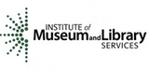 | 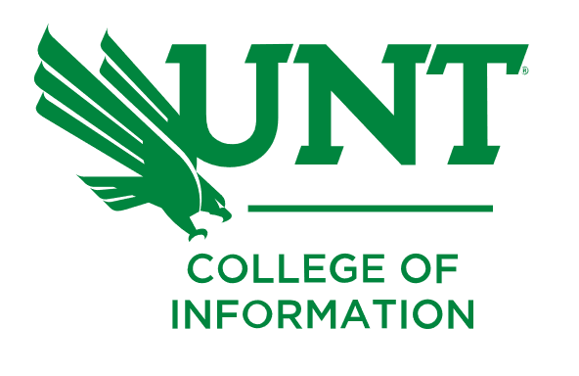 | 